Simple steps for food and health:
Indigenous families in Canada

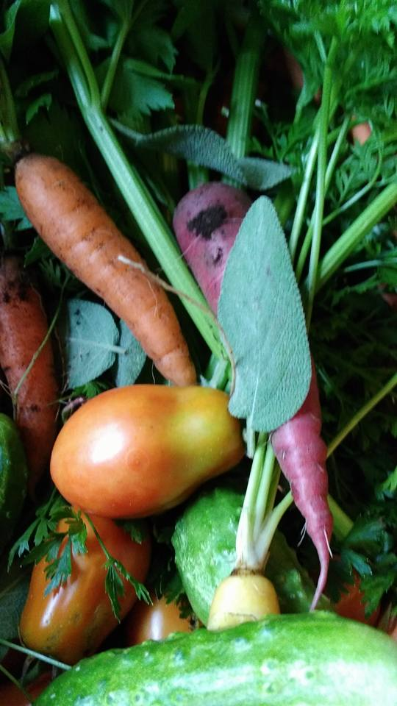

Ontario 2015

Foreword

Greetings friends,

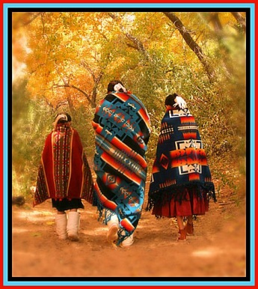
I am an indigenous woman living in Ontario. Mine is a blended family and my husband and I are custodial grandparents; a “kinship” home. Some of our children and grandchildren have exceptional behaviors. Allow me to describe my family’s journey to a cleaner, healthier, and more wholesome life. I offer you this story as a way to encourage you to be vigilant about the things we put in our family’s mouths and on their bodies, and realise how nutrition plays a vital role in how we think, how we feel, and how we act. Knowledge is powerful.

One evening at bath time I noticed that my seven year old granddaughter’s chest seemed swollen. I asked her if she had fallen or if her chest was sore. “A little”, she replied. I mentioned this to my adult daughters, now mothers, and they jokingly replied “Well mom, she has to grow up!” But I felt this wasn’t prepubescence at age seven.

From the media, I had become conscious of the enormous amount of additives in our food sources. I had the basic understanding that too much processed foods was not good for us. I had assumed that food security regulations existed that protected us from poisoning ourselves, and that laws existed to control the toxicants in our environment. I had accepted that there has to be some pollution in order for the “world to work”, for Kellogg’s to make the cereal, for Lego to make building blocks, for cell phones to be made with heavy metal mining.

What I have come to learn is that I was wrong to leave the health and well-being of myself and my family to the multi-levels of bureaucratic system required to operate by the measure of profit. I became more aware of what I was purchasing, not only for nutritional values but the packaging and amount of pollution created to bring those items home.

The following year, I brought our granddaughter to the doctor’s since her chest had remained swollen. Just as my daughters, a nurse stated that she is just growing up. I balked against breast development before the teen years, and was told that even younger girls were developing the same way.

In a moment of insight, I realised that food was the cause. Our granddaughter ate an enormous amount of cereal. She was a picky eater and refused to eat what the family was eating. In order to have dinner together, we would let her have cereal. Cereal before bed, for lunch, for snack food. We bought some “healthy” granola of which she would have no part. At that light bulb moment in the nurse’s office, I knew that cereal would have to go and the worse battle of my life was on.

Raising children with exceptional behaviors, you learn negotiations strategy a United Nations delegate would admire. I knew I had to come up with some extraordinary reward to lessen the impact of the change in diet. Kids naturally like to cook, so making breakfast was the new thing. So we started our work in the kitchen together, making simple but nutritious breakfasts like eggs, muffins, even French toast! Eventually she began cooking independently (but supervised) at Nan’s stove, choosing the right pans, selecting ingredients, and learning cooking terms.

There were times of complete meltdowns of grief over the lost cereal, and grocery stores tantrums reached a new height. Erratic mood swings increased and then receded. The swelling in her chest reduced, and the colour of her complexion went from pasty to a healthy pink. It hasn’t been easy. The key was to be confident and unwavering. I set out to determine if eliminating cereal from our family’s diet would improve our health overall, and found that in our case it absolutely did. In a small way, we had fought successfully against the giant sugar industry, the cereals industry, genius marketers, and untruths in the media.

Researching nutrition has now became a passion of mine, and it’s my goal to pass along to you the most important findings in this family health guide. After doing extensive research, I am convinced that good nutrition and whole clean food is a major part of the solution not only for everyone but for many of the exceptional behaviours that children exhibit.

Friends, I hope you are inspired, I hope you are inquisitive to take this health journey, and I hope for good health to you and yours. Cultural nourishment helps to grow the family, community and nation. The sharing of this information helps to plant the seeds for a lifelong learning journey. I invite you to journey with us.

Peace & blessings,
Lola

Table of Contents

The Medicine Wheel

Your Needs Checklist

A Step-by-Step Guide to Managing Health
Cleansing the Body
Cleansing the Home
Cleansing the Community
Healing Individual Needs
Maintenance

List of home healing supplies

Effective natural remedies and traditional practices

Traditional Foods

Approaches for youth with behaviour issues

References

The Medicine Wheel

The circle of the medicine wheel symbolizes a healing circle. Healing circles help people speak about the mental or physical emotional and spiritual selves.

Medicine wheel directions:
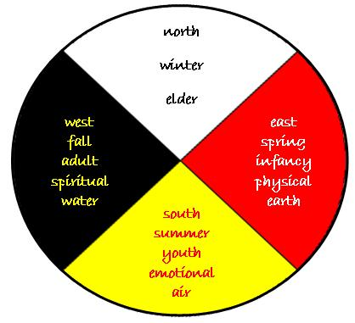
east, west, south, north

Seasons:
spring, summer, fall, winter

Elements:
water, fire, earth, wind

States of being:
mental, emotional, physical, spiritual

Sacred medicines:
tobacco, sage, cedar, sweet grass

Planning stages:
vision, feeling, time, movement

Aspects of a person’s life:
spiritual, physical, mental, emotional

Phases of life:
child, youth, adult, elder

The Medicine Wheel represents all of creation, harmony and connections. It is considered a major symbol of peaceful interaction on Earth (all races of people, the directions, all of the cycles of nature, day and night, seasons, moons, life cycles, and orbits of the moon and planets). The basic Medicine Wheel of the Four Directions can be expanded to include other wheels. These wheels within wheels are used to explain and examine things that impede personal growth, and the development process that involves leading a person to wholeness. All Medicine Wheels are tools for people to learn about their place in the universe and their relationship to all things created.

Numbers have always played a significant part in traditional Aboriginal life. Four is one of the most sacred numbers used in Aboriginal culture. Many aspects are seen in terms of four.
Sacred Medicines
There are many kinds of Sacred Medicines used, with the most common being Sweet Grass, Cedar, Sage and Tobacco. These can be burned or given as a sprinkled offering. When the herbs are burned, the smoke serves as a cleanser for the body and takes prayers to the Creator. When sprinkled, it is a sign of thanks to the Creator for all things, and acknowledges the gifts of the trees, plants, fungi, birds, the four legged and the two legged ones, the swimmers and crawlers the winged ones and insects. An abalone shell is used this shell represents water the first element.

Many use the Sweet Grass in ceremony as a ritual cleansing this to help cleanse the body, mind and spirit. The three-fold braid of the sweet grass represents, mind-body-spirit. On the medicine wheel, sweet grass is in the north direction

Cedar serves as a protector. On the medicine wheel cedar is in the South direction. Due to the vitamin C it contains, in past times cedar was used to prevent scurvy when vegetables and fruits were scarce.

Tobacco is a sign of respect to the Creator. It is east on the medicine wheel, and has been used in traditional ceremonies, rituals, and prayers for thousands of years to give thanks to the Creator and Mother Earth. It is also used to communicate with the spirits to purify the mind and heal the body. Traditional tobacco comes from many different plants which exist in the wild in North America and is best used in its original form for traditional ceremonies. Tobacco in its original form had both honour and purpose. Besides being bundled and burned in a sacred fire (called smudge), traditional ways of using tobacco include putting it into sacred pipes for certain ceremonies. The smoke from the pipe is not directly inhaled. Some people make an offering of tobacco while walking. The tobacco is placed on the ground or floor as the person prays and gives thanks to the Creator. Elders caution that traditional use is different from recreational use of commercial tobacco products, and that sacred tobacco should not be abused. First Nations elders maintain that recreational use of tobacco is disrespectful to the spiritual, medicinal and traditional use of tobacco.
Sage is west on the medicine wheel, and is a women’s medicine. Sage promotes good feelings and balance. It is said that the smell of burning sage releases beta-endorphins that give us clarity of purpose and strengthens our resolve for feeling positive.

A smudge is another traditional ceremony practised by some to physically or spiritually cleanse negative energy, feeling or thoughts from a place or a person. During a smudging ceremony, sacred medicines such as cedar, sage, sweet grass, and tobacco are burned. The person puts their hands in the sacred smoke and carries it to their body, especially to areas that need spiritual healing. A smudge stick may also be used.

The Medicine Herbs
From the beginning they were instructed to take away sickness. They are always waiting and ready to heal us. We are happy there are still among us those special few who remember how to use these plants for healing. The plants grow, working many wonders and sustaining life forms.

The Food Plants
The Food Plants are those that we harvest from the garden. Since the very beginning of indigenous cultures, grains, vegetables, beans and berries have helped peoples survive. Many other living things draw strength from them too. The Earth has many families of Trees who have their own instructions and uses. Some provide us with shelter and shade, others with fruit, beauty and other useful things. Many people of the world see the tree as a symbol of peace and strength.

The Waters
Water is the first element on the medicine wheel. The waters of the world are for quenching our thirst and providing us with strength. Water is life. We know its power in many forms, waterfalls and rain, mists and streams, rivers and oceans. Now our minds are one.

Your Needs Checklist
This is where you work starts. For yourself and your household, determine what you want to focus on. Choose the biggest health struggles and resolve those first, then include lesser ones. Record them all in the chart below.

Remember to be specific! Instead of “get in shape”, write down “take a 10-min walk once a day”. Note that at this point you don’t need to come up with solutions, just list the problems.

Health issue | Present since | Affects person | Notes

A Step-by-Step Guide to Managing Health:
Cleansing the Body
Cleansing the Home
Cleansing the Community
Healing Individual Needs
Maintenance

Overview
Good health is judged by how well our bodies adapt to internal and external environments. If your body is functioning optimally and you are exposed to viruses or bacteria, you should be able to neutralize them without even being aware it is taking place.
Our bodies are self-regulating and self-repairing. Understanding and listening to our bodies is the key to our wellness. Wellness means taking responsibility for our health and life journey.

Good health is not something we can achieve by taking a herb, pill, potion or lotion. Thinking about your health is a step closer to improving it. Each small change will result in a healthier happier you. Be patient with yourself. Positive self-talk is useful, even if you are eating or drinking things you know aren’t healthy. Try not to self-sabotage or give up on making the next health choices. When you think about life you may find that we are constantly changing baby teeth fall out, skin cells die off. Every moment we are changing. Challenge yourself to stretch beyond the limits and definitions you have self-imposed and grow to your fullest potential.

Good health is an active function that requires your participation. Meet your body! Take time to look at your hands, your feet, your face. Smell your children’s hair, become attuned to how they are feeling every day. Body awareness is integral to charting your personal wellness journey.

Sharing this growing experience with family and friends may inspire others to start the journey on their wellness path. Small steps, big changes - you’ve got this!

Cleansing the Body

The healing compounds that are meant to fortify our bodies against toxic breakdown are missing from most of the foods that most people eat every day, resulting in an epidemic of nutrient deficiencies. Mass food processing methods like using heat, pressure, and radiation severely diminish food of its life force, naturally occurring enzymes, and nutrients. These processed “foods” also place a tremendous burden on the digestive system, compromising the immune system and greatly contributing to the cancer epidemic.

Most packaged foods in cans, bottles, boxes, and plastics contain added chemical toxins that have been deemed “safe” by various government regulatory agencies, even when they’re not. A short list of these chemical toxins includes things such as preservatives (to extend shelf-life), artificial colors, artificial sweeteners (such as aspartame), artificial flavor enhancers, and a multitude of food conditioning agents – emulsifiers, anti-foaming agents, anti-caking agents, stabilizers, thickeners, modified starches, gelling agents.
There are over ten thousand chemicals that are labeled Generally Recognized as Safe (GRAS) by the food industry. By labeling them as GRAS, food companies can then take advantage of a loophole that allows these chemicals to be approved for use without ever having to be tested for long-term human safety. If you look for these ingredients on the label, sometimes they aren’t even listed. If you want to live a long and healthy life, eat food with a short shelf life. Whole foods are foods that exist with little change in nature. Fruits, vegetables, grains, nuts, seeds, milks, and animal foods including beef, fish, poultry, pork, and eggs are all whole foods, and should make up most or all of your diet.

GMO Foods
Back in the mid-1990s, the fields of science and chemistry came up with a way to produce foods using foreign DNA not present within a particular plant species. Genetically modified organisms (GMO’s) involves injecting the genes of, say, a fly into the genetic helixes of tomato plants – a completely unnatural process that’s not yet been shown to be completely safe for humans, animals, or the environment. GMO’s come with potential health risks not fully assessed under existing regulatory protocols. These health risks include gastrointestinal disease, DNA damage, and cancer, as revealed in hundreds of independent scientific studies. GMO’s do not contain the same nutrient levels as non-GMO
and organic foods. The Non-GMO Project lists the following foods as the most common foods to avoid in the Canada and USA food supply including Soy, Corn, Canola, Sugar beets, Hawaiian papaya, Yellow squash, and Zucchini. If you eat animal products (i.e. meat, eggs, and milk) you should choose it from livestock raised on clean pasture rather than in commercial feedlots.

Meat from animals fed grass rather than corn and soy feed (what most conventional feedlot cattle are fed) contains much higher levels of omega-3 fatty acids. Omega-3s are one of the “good” dietary fats that helps revitalize the cellular system and promote heart health. Chickens that forage on pasture produce eggs with rich, orange yolks which are shown to protect against colon cancer. Consuming meat from hormone-injected animals is also problematic. Look for the words “Non-GMO Certified,” “Certified Organic,” “Pasture-raised”, and “Grass-fed.” Even better is “100% Grass-fed” as this indicates that the animals received no grains as feed (and have the lowest levels of unwanted omega-6 fats and highest levels of omega-3 fats).

Dairy
Pasteurization (heating) kills beneficial enzymes and other nutrients that help boost your immune system.

Water makes up more than 75% of our muscular system and upwards of 93% of our bloodstream; water is an essential component for a healthy body. Although we have relatively clean water in Ontario, Harvard University study found that a child’s IQ is directly hampered by exposure to fluoride in drinking water. Even at levels considered safe by the government, children exposed to fluoride may have impaired brain function and neurological development. If a home water filtration system isn’t feasible, the next best thing is to drink bottled filtered or spring water.

What can I do?
Buy organic foods, or if they are too expensive or unavailable, use the ACV method. Soak produce in enough water to submerge it, along with one tablespoon of ACV. Place a plate over the bowl to keep produce submerged, and set aside. By using the non-GMO guide you can avoid eating food covered in pesticides.

Grow your own food! You need surprisingly little space for this and it can be done even in apartments, using containers, living roofs, hydroponics, or community gardens. A simple window garden will produce an amazing amount of herbs for culinary use and medicine. Using an old dresser is a creative way to garden. Simply remove the drawers then flip the dresser on its back. Put soil in slots, then plant. There are many books that can give you some tips. As a bonus, planting a seed and tending plants is a natural stress reducer.

Clean Produce
A reputable organization called The Environmental Working Group (EWG) has created a list called the Dirty Dozen. These are the fruits and vegetables that are highest in pesticide residue when conventionally grown. You should avoid these items if you can’t get them organic or certified pesticide-free:

1. Apples (99% of samples tested contained at least one pesticide residue)
2. Peaches (98%)
3. Nectarines (97%)
4. Strawberries
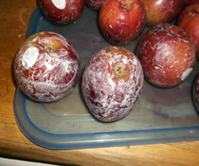
5. Grapes
6. Celery
7. Spinach
8. Sweet bell peppers
9. Cucumbers
10. Cherry tomatoes
11. Imported snap peas
12. Potatoes

The EWG also lists what they call their Clean 15 – the produce that is least likely to contain pesticide residue when conventionally grown. Ideally you would buy only organic or certified-free produce, but it you can’t, these are the items that land on the clean end of the pesticide spectrum:

1. Avocados
2. Sweet corn
3. Pineapples
4. Cabbage
5. Frozen sweet peas
6. Onions
7. Asparagus
8. Mangoes
9. Papayas
10. Kiwis
11. Eggplant
12. Grapefruit
13. Cantaloupe
14. Cauliflower
15. Sweet potatoes

Detoxing
Identify and rid your home and work space as well play areas of toxic hidden chemicals in your food, water, personal care products. Eat as close to nature as possible to reinforce your immune system to become a protector against virus, illness and disease. Use brands and products that are safe for you this will significantly minimize your exposure to toxicants and improve your immune system.
Detoxing the body, we must have prepared a clean route to dispose of the toxic waste. Clean the colon. By adding healthy oils we can gently flush our system.
Alkalising our system provides us with a functioning intestinal tract that correctly digests our food and absorbs the nutrients at a cellular level feeding boosting our immune system.

Oxygenating our bodies prevents the development of viruses’ illness and disease as well as boosting our positive energy. Movement is a vital component to ridding our bodies of toxicants. Jumping and running or walking, movement that will get our core temperature up by a degree. This will stimulate muscles and the blood circulates more efficiently and effectively assisting in the bodies’ expulsion of toxicants.

Our modern lifestyles expose us to harmful toxicants. These unnatural poisons build up in our bodies, eating processed foods or restaurant foods chances are you are routinely eating genetically modified “foods”. Chances are you should cleanse your body systems. Cleansing or detoxing our bodies allows the body to get rid of toxicants and allows beneficial bacteria to naturally self-regulate and self-repair our digestive system. Cleansing restores the natural flora balance in our gut. Removing home toxicants such as aerosol and avoiding foods with sugar or wheat or dairy will help keep our bodies self-regulating and functioning naturally.
Who should detox?
A gentle detoxification, for anytime from a weekend or a week, is safe for mostly healthy individuals but is not recommended for those with serious illnesses, the elderly, and pregnant women. For children and teenagers, a solid-food detoxification (as opposed to liquid-only detox) should be fine as long as enough nutrients are being consumed daily. If you are unsure about detoxing, see your medical or natural health practitioner for guidance.

When
Detoxing begins the moment you start to rid your environments from chemical toxicants. Some people like to do this every spring, when we are physically and emotionally preparing to “renew” our bodies. Cleansing yourself of toxicants and restoring balance begins when you stop eating sugar, wheat, and processed foods. A wholesome diet with plenty of greens will ensure you are naturally clean. Again, connect with a medical or natural health practitioner whose knowledge and guidance you can share your wellness journey with.

How to Detox
Trying to follow even a few of these steps every day will help to correct some problems caused by toxicity.

- Drink at least eight cups of filtered water a day. One of those cups can include a tablespoon of Mothers Apple Cider Vinegar or lemon.
- Eliminate properly: Keep your bowels moving, at least once a day. If you need help, take two tablespoons of ground flaxseeds in water, or a probiotics capsule. If you have any chronic problems, you have to be careful about taking supplements and should work with your doctor.
- Eat clean: Try to buy (within budget) as much organic produce and high-quality animal products as you can
- Eat cleansing food: Aim for at least 8 servings of colorful fruits and vegetables a day, particularly those in the family of the cruciferous vegetables (broccoli, collards, kale, cabbage, Brussels sprouts, kohlrabi) and the garlic family (garlic and onions)
- Avoid stimulants, sedatives, and drugs, such as caffeine and nicotine, and alcohol intake.
- Get moving: Move your body enough to get your heart beating faster, a minimum of 20 minutes, five days a week. Try to include conditioning your cardiovascular system, strengthening exercises, and stretching exercises.
- Avoid the white menace! White flour and sugar.
- Relax deeply every day to get your nervous system in a state of calm, rest, and relaxation.

Cleansing the Home

There are over eighty thousand chemicals currently in our personal care products that have never been fully safety tested by federal regulators. Even worse is the fact that a great number of these chemicals have been shown in independent testing to cause cancer and other serious health problems.
Tooth paste
Fluoride, an industrial waste product linked to lowered IQ in children and dental fluorosis, or mottling of teeth. 50 years of collective science says fluoride is harmful.
Triclosan, an antibacterial chemical that disrupts hormone production and promotes multiple forms of cancer, including breast, ovarian, testicular, and prostate cancers.
Recommended alternatives: Dr. Bronner’s All-One Toothpaste, Auromere Ayurvedic Toothpaste, Tom’s of Maine Natural Toothpaste, Spry Dental Defense Toothpaste.
Homemade alternative: Mix baking soda mixed with coconut oil.

Each of these toothpaste products contains cleansing and protective herb extracts such as neem, wintergreen, mint, and cinnamon derived from the essential oils of actual plants and herbs. Neem was shown in a 2011 study published in the Journal of Indian Society and Periodontology to safely and effectively treat plaque-induced gingivitis due to its powerful anti-inflammatory properties.

Mouthwash
A study published in the journal Free Radical Biology and Medicine found that many popular mouthwash products contain an ingredient known as chlorhexidine that destroys this bacteria, weakening the immune system. Some studies have also linked added alcohol in some mouthwashes to oral cancer. In dental floss the use of a chemical known as perfluorinated polymer, or PFC. This cheap replacement for natural wax interferes with hormone and immune function.
Recommended alternatives: Radius Floss, Eco-Den, T Premium Dental Floss, Desert Essence Dental Floss.
Homemade alternative: Swish coconut oil in mouth, and then rinse with warm water

Hair Care
Another area of concern are shampoos and conditioners for your hair, many of which contain parabens (a type of preservative linked to breast cancer), synthetic “fragrance” chemicals, sulfates (a detergent and surfactant), and other chemicals linked to various forms of cancer.
Recommended alternatives: Dr. Bronner’s Pure-Castile Liquid Soaps or Aubrey Organics and Himalaya Hair Care
Homemade alternative: A half and half mixture of ACV and water used as a rinse helps get hair cleaner and increases shine.

Hand and Body Lotions
A class of emulsifying ingredients (emulsifiers basically thicken lotion and give it a consistenttexture) known as alkyloamides used in many of them can convert into cancer-causing agents known as nitrosamines.
Recommended alternatives: The simplest, safest and most effective way to moisturize your skin is to use pure moisturizing oils, either from or with coconut oil, shea butter, or jojoba oil.
Homemade alternative: Shea butter or coconut oil. For a facial, combine egg white mask with warm water and lemon, then rinse.

Soaps are a source of carcinogens if they contain ingredients such as benzyl acetate, a perfume chemical linked to liver adenomas, carcinomas, stomach tumors, and pancreatic cancer. Sodium laureth sulfate, or SLS, is duly mutagenic, meaning it damages cellular genetics. It also inhibits the skin’s ability to retain moisture.
Recommended alternatives: Dr. Bronner’s Pure-Castile Liquid Soap and bar soaps Nubian Heritage or One with Nature.
Homemade alternative:
2 tablespoons raw organic shea butter
1 tablespoon unrefined coconut oil- solid at room temp (can use extra shea butter if allergic to coconut)
2 teaspoons olive oil OR castor oil
2 teaspoons beeswax
20+ drops of essential oil of choice (optional) chamomile, geranium and orange

Deodorant and antiperspirants on the market today contain toxic aluminum, a metal compound that blocks the pores in your armpits, inhibiting detoxification through sweat? Aluminum is also a neurotoxin that a study published in The Journal of Applied Toxicology found deposits itself into breast tissue after being absorbed through the skin.
Recommended alternatives: Primal Pit Paste, Crystal, Young Living
Homemade alternative: Mix a little bit of baking soda with a small amount of water and rub it under your armpits. If reducing wetness is important to you, you can skip the water and mix one part baking soda with six parts corn starch (look for a variety that isn’t genetically-altered also aloe Vera, add an absorbent medium such as baking soda.

Hand sanitizers are also typically loaded with triclosan (just like hand soap), its cousin triclocarbon, and synthetic fragrance chemicals.
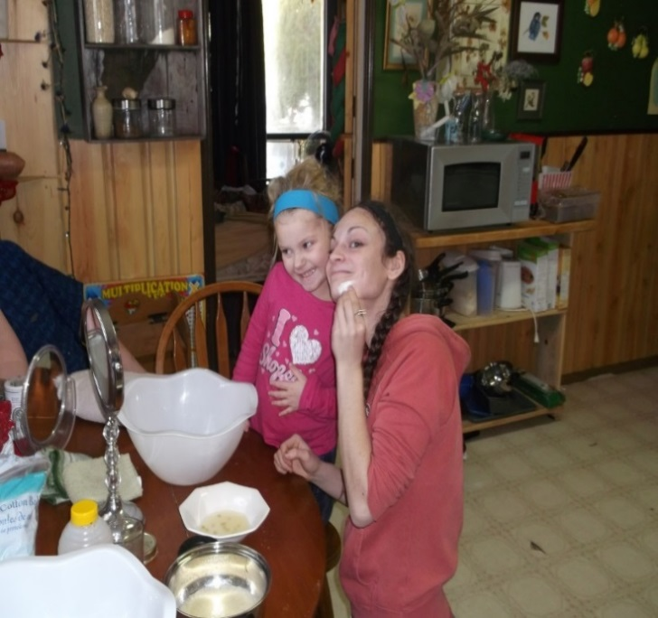
Homemade alternative: 5% solution vinegar/ white in a small spray bottle, white vinegar products sold at grocery stores work just fine and is 99% effective against bacteria, and is completely non-toxic.

Sunscreen
Most commercial sunblock products contain many harmful additives. Many commercial sunscreen manufacturers synthesize zinc oxide and titanium dioxide, the two most common active ingredients in sunscreen products, into nanoparticle form. This means the particle sizes of these ingredients are made unnaturally small, which poses health risks due to easy absorption.
Recommended alternatives: Choose only natural, sunscreen products containing mineral based, non-nanoparticle versions of either titanium dioxide or zinc oxide, both of which provide physical protection against the sun’s rays without leaching dangerous chemicals into your body and skin. Another great option for sunscreen protection is to supplement with natural astaxanthin, a potent carotenoid antioxidant found naturally in salmon.

Feminine care products can contain chlorine (a bleaching agent), dioxins, plastics (bisphenol-A and phthalates), synthetic fibers, and various petrochemical additives, synthetic fragrances and chemical-based odor neutralizers.
Recommended alternatives: Seventh Generation or Natracare and Glad Rags – they contain no plastics and are also reusable, which is a significant money-saver.
Homemade alternatives: make your own pads! See sewing tutorials online.

Baby Wipes and Diapers
The World Health Organization (WHO) warned in a 2003 report that a chemical by product commonly found in both baby wipes and diapers is a “persistent environmental pollutant,” meaning it doesn’t break down very easily. This causes all sorts of health problems, including developmental delays and cancer. There are chlorine-free, fragrance-free, and mostly chemical-free options such as BAMBO Nature “eco-friendly” diapers, but even these still contain SAP. Baby wipes contain alcohol, phthalates (a family of plastics chemicals often used in personal care products), parabens, phenols, SLS, and other harmful additives.
Recommended alternatives: Cloth diapers.

Home
A report by Women’s Voices for the Earth found that many conventional cleaning products, including those branded as “green” contain hidden carcinogens. Toxic substances aren’t always listed on ingredient labels, which can make it difficult to know what’s safe to buy.

Dishwashing detergents and dish soaps are cesspools of endocrine disrupting chemicals, carcinogenic substances, and unknown by products of questionable origin.
Recommended alternatives: Seventh Generation, Earth Friendly, Better Life and Honest.
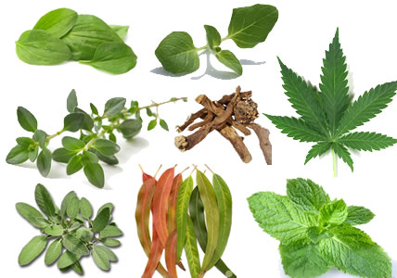
Homemade alternative: Combine two parts Borax with two parts washing soda (a derivative of baking soda).

Cleaner
Homemade alternative: Mix 1/2 cup vinegar and 1/4 cup of baking soda into two quarts of water.

Air fresheners are among the most toxic products you can bring into your home and work place.
Recommended alternatives: All-natural essential oils and a diffuser are best. Mountain Rose Herbs, and Hopewell are excellent brands of essential oils.
Homemade alternative: open windows or simmer lemons ginger cinnamon or cedar or burn Sage

Shower curtains contain PVC (polyvinyl chloride) shower curtain liners (the kind most people have in their bathrooms) are incredibly toxic. They are often outgassing dangerous vocs (volatile organic compounds) such as xylene and toluene, as well as dioxins, endocrine (hormone) disruptors, and even cadmium and lead.
Recommended alternatives: A PEVA vinyl shower curtain.

Cookware labeled as “non-stick” or “Teflon,” made from carcinogenic substances. The National Institute of Environmental Health Sciences is currently investigating these substances as a likely cause of cancer. Even the popular anodized aluminum cookware is questionable. The various polymer-based coatings used in their manufacturing may pose serious health risks due to chemical leaching and outgassing.
Recommended alternatives: Stainless steel, cast iron, and copper.

Cleansing the Community
Every community could use some volunteers to clean up public spaces. This is a great way to get exercise meet new people and share your wellness journey. Join or start a community garden. Walk to get your necessities whenever possible. A brisk walk to the post office or library can be exhilarating.

Toxic people
We all have friends or family or even community members who are negative nellies. Those people who complain about everything. Try and limit your exposure to the negativity. When you do have to socialize and this toxic talk begins trying shrugging it off and saying something positive. Remove yourself when possible. People will behave as they have been allowed not giving that person attention my change the tone of the conversation the next time you meet or speak.

Stress management
Exercise is the best way to reduce stress. Movement, listening to music and dancing is a fun way to exercise. Ice skating is a Canadian favorite winter activity. Movement that takes exerted effort to where the body perspires. Your circulatory systems’ will be thanking you with abundant energy.

Addressing mental health issues
Many mental health issues can be addressed by knowing about nutrients and nutrition. Having a wellness guide will be beneficial to those concerned about this. Exercise, spending time with a pet or volunteering at your local shelter to walk or groom animals would be a fantastic way to increase your sense of wellbeing. Smudging is another idea to relax your mind soothe your spirit rejuvenate your body senses. Hugging is a magnificent way to reduce stress and share the good vibes that wellness provides us.
.

Healing Individual Needs

Now that you know much more about improving the body, home, and community, it’s time to revisit your checklist to see what can be done. To make a strategy plan, use the chart below. Revisit your needs checklist from before and see what can be done.

Remember that change takes time, and you’ll need to keep experimenting with remedies and doing research to find the best fit for your family.

Health issue | Present since | Affects person | Solutions to try

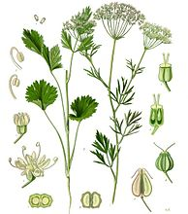

Maintenance

Once you have made the commitment and initiated lifestyle changes, you will feel great! Maintenance shouldn’t be a concern. Keep trying to change little things and seeing what works best for you. Learning to understand and listen to our bodies, we gain confidence in our ability to maintain good health and wellness. Enjoying the beauty of nature rejuvenated with a spirit of vitality and eagerness to experience life’s marvels, you will naturally continue to seek and make health and wellbeing choices that compliment your wellness journey.

“The child teaches us what life is going to be like; No one just gets up and walks for ever, you will fall and you will get up and try again. The child’s life teaches, to be persistent in getting up and doing things again.”

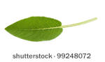

‘

Your list of home healing supplies
Here is a starter list to keep on hand at all times. Some of these are one-time cost and some must be replaced more frequently.

Your regular grocery list can include items like dried peppermint, fresh ginger, vitamins B, C, and D, garlic, lemon juice, and raw local honey.

Item | Estimated cost | Where to Buy
Small coffee grinder | $10 | Houseware or department store
Emulsifier or hand wand | $15 | Houseware or department store
Apple Cider Vinegar with the Mother | $10 | Natural food stores
Neti pot | $15 | Drug store
Essential oils: tea tree, lavender, eucalyptus | $25 | Natural food stores
Dried plants (10 oz. of each): elderberries and Echinacea root | $15 | Natural food stores
 | TOTAL $90 | Great Value!

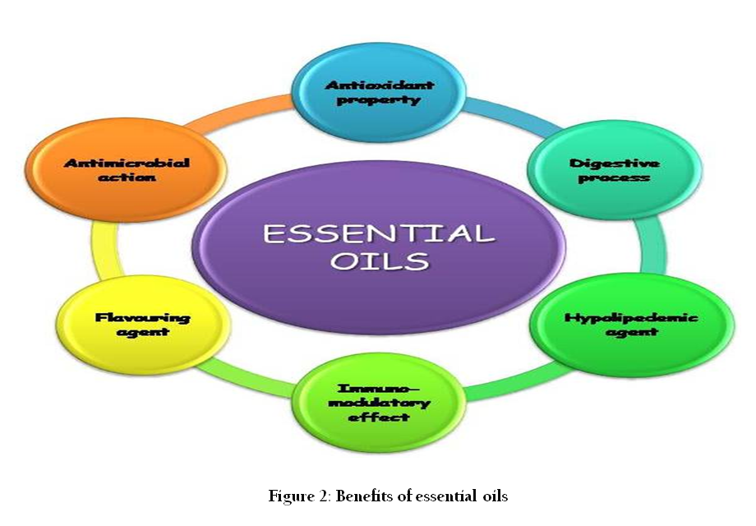

Natural remedies and traditional practices

General Immune Support
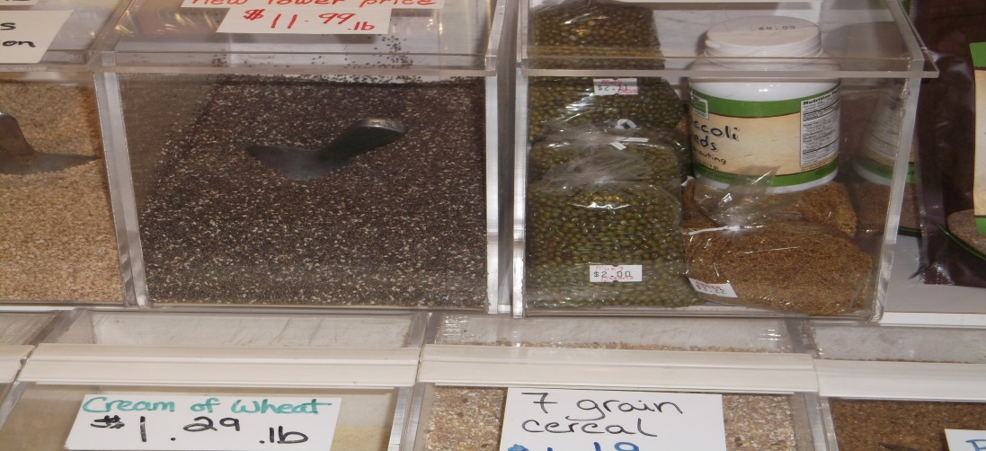
With a simple coffee grinder and emulsifier/hand blender, you can prepare nearly all remedies. Purchase whole seeds and grind them at home, because the nutrient value dissipates once the seeds are ground. Add ground flax seeds to your food; sprinkle on salads, sandwiches, cereal, cake mixes or baking goods, yogurt, or use the emulsifier to whip together with some favorite frozen berries. Add live Apple Cider Vinegar to a jug of juice or water. One ounce or less will slightly alter juice taste. You can also mix into your regular salad vinaigrette.

Aches & Pains
There are many simple and free remedies for general aches. Do yoga (or stretching), stand out in the sun, or use a heat pack on the area.

Allergies
A Type 1 histamine reaction is produced when exposed to allergen. If you have seasonal allergies, try consuming more dried nettle and a quercetin supplement daily, one month before your allergies usually begin.

Bug bites
The easiest remedy for summertime bug bites or stings is right next to you. Look outside for broad-leaf plantain, one of the most common weeds and easy to identify. Mash or chew up and apply to the skin for several minutes. This will even help to reduce inflammation and pain for bad wasp stings.

Chills
During the winter it’s common to feel chilly nearly all the time. The simplest way to warm up is to move your body, wearing layers that you can remove or add back on. Hot tea with fresh ginger slices, cinnamon, and cayenne pepper will also warm you up, as will a hot foot bath with rosemary oil.

Common Cold & Flu
At the first sign of a cold, cut out sugar and white flour from your diet. Make a large pot of vegetable soup, and roast some chicken and root vegetables in the oven. Chop some onions and place them in rooms, with a humidifier. At night before bed, grate an onion and put a small amount of the juice on bottom of foot, then cover feet with socks. Drink lots of green tea with Echinacea leaf, to help keep immune system boosted. Don’t forget your ACV in a cup of water, several times a day! Plus many cups of regular hot water. To give a virus a powerful punch, mince one clove of garlic and mix with ½ cup of warm water. Drink it all down quickly (best not to think about it!), preferably on an empty stomach.

Cough
During cold season, a cough can go on for weeks. To soothe your throat and bronchial passages, make a simple cough syrup good for adults or kids. In a heavy-bottom pot, mix 4 cups of water with ¼ cup each of marshmallow, ginger, cinnamon, dried red clover, and lemon juice. Let simmer for 1 hour, then strain and add a cup of raw honey. Take 1 tablespoon several times a day to soothe a wet or dry cough.

Earache
Doc Shillington’s Total Tonic Formula:
1 Handful of Garlic Cloves
1 Handful of chopped Onions
1 Handful of chopped Ginger
1 Handful of chopped Horseradish
1/2 handful of chopped Habanero Peppers
Throw all in a blender and cover with an inch or two of organic apple cider vinegar.
All ingredients should be organic, but don’t let that stop you from making this great formula. You can use the mash right away or wait two weeks and tincture.
At the very first sign of an external ear infection, use ear drops.

Doc Shillington’s recipe for Earache Formula:
1 cup of organic cold pressed olive oil
2 tablespoons of powdered mullein
3 medium sized cloves of garlic
Put ingredients in a blender and puree. Pour into a jar that is kept in a dark place for two weeks. Shake the mixture daily. Strain and press. Bottle. For a bad infection, increase the garlic. For children use only two cloves of garlic. Eliminating dairy can make a difference in the frequency of ear infections. Avoid sugar as it depresses the immune system.

Eczema
Bear fat rendered down to grease can be used for eczema or other skin ailments. Also avoid dairy (cow’s milk, ice cream, yogurt, cheese) for at least 2 weeks, to see if it makes a difference as this can exacerbate the condition.

Headache
A tea of rosemary, peppermint, willow bark, and feverfew is an excellent remedy. You can also try some sandalwood oil on the back of your neck.

Skin
Make a salve that is gentle enough to be applied to nearly all skin complaints, except open wounds. Pour 1.5 cups of coconut oil and 3 tablespoons of grated beeswax into a small pan. Add 2 tablespoons each of dried calendula, chickweed, comfrey, plantain, and lavender. Most of these can be foraged. Simmer for 2 hours, then strain and bottle. Store in a cool place for up to 3 months.

Sore Throat
One of the worst things about a cold is the sore throat, which can go on for days. At the earliest onset, combine a cup of water with 1 tablespoon of ACV and drink 4 cups of this a day. As well, take a zinc supplement. Raw local honey works well taken alone or in tea, and if you are making tea anyway put in some sage, thyme, and lemon with it.

Toothache
Crush 5 whole cloves with a teaspoon of olive oil. Apply with a Q-tip to the gum line.

Traditional Foods

Snow can be used to stop nose bleeds. Place snow on nape or back of neck or bridge of nose. Drip seal fat on eyes for snow blindness. Head lice are tied to a hair strand and placed on eyeball and the sticky legs of the insect picks up the white film that develops when someone has snow blindness.

Seal fat is used for many health aliments of the Inuit peoples. Boiled seal fat for lung ailments; coughing. For sore throats chew seal fat. Drip it into the ear for earache.

Ptarmigan
Raw ptarmigan breast meat is eaten by chronically ill people who have lost their appetite, and it is used in thin slices on boils, on the neck (for a sore throat), or on the eyelids of a snow-blinded person. The dried neck skin is used to cover cuts and burns, and the thigh skin may be applied to a boil. Ptarmigan down mixed with rancid seal fat or just raw ptarmigan oil may be used to treat a cut.

Loon
It is a common cure to eat a whole loon or red-throated loon. Usually raw, sometimes boiled, the whole bird must be eaten, if not at one meal then at least in one day. Often, the gall bladder or the top part of the esophagus must be eaten first. This treatment is for people who have tuberculosis, asthma, seizures, or children who have fainted during a fit. Also, dried loon intestines are chewed to relieve a stomach-ache.

Other birds
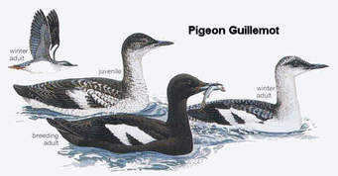
Goose oil is used raw on cuts, and the thinner bone of a goose wing is hollowed out and used as a “straw” to help extract pus from a boil. Raw owl oil is used on cuts and impetigo, and the skin from a black guillemot (pitsiulaaq) is used to clean the inner eyelid.

Wing feathers of any bird are useful. The outer (soft) end of a feather is used as a dropper for earache drops (it is sharpened first) or used to test the temperature of boiling oil; if it burns, the oil is ready.

Chaga
The chaga mushroom (inonotus obliquus) is a medicinal mushroom that grows in northern Europe, Siberia, Asia and North America. It grows for seven years inside the bark of wounded or mature birch trees, and it expresses itself outside the bark in the form of a blossom that looks like burnt coal and feels like cork. Chaga mushroom can be used as a remedy for chronic inflammation, diabetes, hypertension, cancers, stomach illnesses and improving the immune system.
It is a polypore, which puts it in a category of mushrooms that are mostly edible and always non-poisonous. Chaga is wild-crated and not cultivated which means you will only find the actual mushroom in a forest area. Brewed into a tea, it can be sipped three times a day for ailments such as chronic inflammation. As a tea it is also useful for eliminating stomach ailments. There is a protein in mushrooms called chitin that breaks down cholesterol thereby cleaning the arteries and improving heart health.
Chaga is rich in this protein and in super oxide dismutase (SOD). SOD is a powerful enzyme; it works as an anti-oxidant that repairs cell damage from free radicals. SOD is an extremely important enzyme in that it keeps the body’s cells young and supple. Chaga has more SOD than fish oils, barley grass and vitamins E and C. This ingredient has been claimed as an aid in eliminating immune system diseases like cancer.
Grind it into powder and use small amounts in a cup of hot liquid. Some recipes call for simmering the chaga for several hours, then straining it. Drink warm or cold.

Medicine for the spirit

Fox totem
Patience, wisdom, intelligence, adaptability. Fox people can be high strung or exceedingly calm, charismatic or mysterious, prone to stand out or blend in, keep peace or make mischief. They tend to be partially rooted in the spirit world, living day to day in sort of a 'world between'. Foxes are a strong symbol of femininity, shape-shifting, illusion, and magic.

Bear totem
The bear is an extremely strong symbol of healing and personal strength. Bear medicine is often tied to introspective healing; the need to go within oneself to find answers. The bear is also a symbol of direction and of being able to know when you are on the path that is truly right for you.

Coyote totem
Coyote is a complex symbol of humor, cunning, and survival. Coyote is often portrayed as the 'wise fool', helping people to see the truth in difficult situations. Coyote medicine is often strongly tied to learning to be adaptable, seeing the humor in even the worst situations, and being able to cope with even the toughest things life can throw at you.

Chipmunk totem
Chipmunk people are often spunky, energetic, and trusting. They are often inquisitive and independent, having their own agendas and are not likely to tolerate being told what to do. Chipmunk medicine is deeply rooted in observation and detail.

Approaches for Youth with Behaviour Issues

What’s up with that screaming!
“Functional behavior analysis” is when a child uses a repeated behavior to get a desired result. Two things happen - the child can escape unwanted chore or task, or a disruption changes the environment and the task or chore is stopped or stalled. The child obtains adult attention that is emotionally charged and centered on them, and they also get intense contact and physical touch whether to touch to console or control. Whether this is negative attention or not often doesn’t matter.

Stay calm
Consequences are reinforcing challenging behaviors ask what will the child gain or get out of with the consequences.
Positive behavior support

Analyze triggers
Change the environment. Is there enough independent sitting space, soft lighting, and calm space? Have too many choices recently come available such as groceries. Limit the amount of friends and family weekly visits. Transition can be difficult quietly watching TV can become jumping and screaming just because mom walked by. Whenever possible give notice of change in environment (e.g. 10-minute warnings, 2-minute warning).

Post schedules
Give visual clues like calendars, alarm clocks or sand timers can be useful in providing independent recognition of change transition.

Teach appropriate communication of emotions
Let the child explain why that is upsetting to them. Provide solutions that can help in the future to avoid upset and the challenging behavior.

Revaluate expectations
Is the task over whelming? Can it be broken down into smaller tasks? Is the bedroom a disaster or could putting laundry away one day, toys books next, clear dresser the next? You accomplish getting chore done teaching cleanliness values every day without lecturing.

Reward with personal attention
Go hang out in the bedroom with child, just to relax not to lecture or give advice. Games such as Simon says teach kids to listen carefully to instruction. Dealing with challenging behavior is time consuming for everyone, so be patient with yourself.

Kids: How to raise good parents

Tell them to eat their veggies just like they tell you. Parents often neglect their own nutritional needs. You can help your parents stay happy and healthy by making sure they start their day with something nutritional. Warm water wakes our bodies up gently. Sharing a healthy tea with parents or a snack is a quick nutritional start for parents helping them maintain energy all day. You will be avoiding parental exhaustion and you are helping make a better home.

Parents often forget to exercise. Household chores or traveling to work may not be enough physical activity for them. Physical exercise as kids know is intense movement once you start to perspire, you are beginning to exercise this encourages circulation oxygenates our bodies and lifts up our spirits. Make sure your parents move enough. This will require your encouragement. Take your parents for a walk doing some breathing exercises start slowly parents will let you know when they are ready to race you. Have fun and stay positive even if parents complain, encourage them to keep trying.

Parents need activities that keep them learning. Encourage your parents to listen to new music or to learn a new game such as mine craft any game you can encourage parents to engage in will help them be creative. Hobbies are another great way to encourage parents to be creative. This provides parents with an outlet for relaxation. Also parents will get a sense of accomplishment and family acknowledgement. Kids understand this. Everyone feels good creating things and sharing those creations with family and friends. Raising good parents takes some creative thinking; enjoy each other’s artistic side.

Keeping parents up to date on your life events is another way to keep them happy. Leaving notes on the fridge is a simple way to remind parents of upcoming or current events. Things like picture forms or school trip deadlines may slip their mind. Helping them remember will relax them, and parents will feel good that they completed the form for you on time.

About the Authors

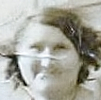

Lola Lawton
Of Inuit descent Lola’s grandmother originated from north shore Labrador. Growing up in her early years by the Atlantic ocean Lola has remained connected to the water and earth. She is passionate about women and children’s wellness and quality of life. Lola is an advocate for the earth and has created many grassroots programs. A grandmother of six and a Stewart for the sacred earth Lola advocate for a natural sustainable world. Lola is passionate about the quality of life and wellness for all especially aboriginal children, youth and families. An imaginer, and story teller and folk art artisan Lola uses her creations to engage children in story telling circles. Lola enjoys wild crafting herbs and sharing the teas of Mother Earth with all who stop by and visit. She may be in a living roof studio or reading in her tipi designed from reclaimed material. Her family values are rooted the Four Direction teachings.
IWHHR,2013 C.G.C.L. certificate 2014.

Ashley Wightman
Of British and Canadian descent, Ashley has been interested in natural remedies for nearly her whole life, and in the last few years has done much researching and experimenting with her family’s healing during common illnesses, including for children. She is a mother, wife, and aunt to many girls. After obtaining her Master’s of Humane Education, she works in administration at Queen’s University and also started a business to help young people explore meaningful work and learning. Ashley hopes to one day grow beneficial and medicinal plants on her own land, and teach youth about best natural healing practices.

Use your voice for kindness
Your ears for compassion
Your hands for charity
And your heart for love.

Megwiich , Niawen'kó:wa , Qujannamiik,
Merci, Thank-you for journeying on the path to wellness with us.

References

The Truth about Cancer: Ty Bollinger

Harvard School of Public Health. Harmful, untested chemicals rife in personal care products. Http://www.hsph.
Harvard.edu/news/features/harmful-chemicals-in-personal-care-products/

Natural Resources Defense Council.
More than 80,000 Chemicals Available in the United States Have Never
Been Fully Tested for Their Toxic Effects on Our Health and Environment. Http://www.nrdc.org/health/toxics.asp

Harvard School of Public Health. Impact of fluoride on neurological development in children. Http://www.hsph.
Harvard.edu/news/features/fluoride-childrens-health-grandjean-choi/

Fluoride Action Network. New Study Challenges Old Belief on Dental Fluorosis/Tooth Decay. Http://fluoridealert.
Org/articles/science-

Fluoride Action Network. Health Effects. Http://fluoridealert.org/issues/health/

Environmental Working Group. Propylene Glycol. Http://www.ewg.org/skindeep/ingredient/705315/PROPYLENE_GLYCOL/

Chatterjee, Anirban et al. 2011. “To Evaluate the Antigingivitis and Antiplaque Effect of an Azadirachta indica (neem) Mouthrinse on Plaque Induced Gingivitis: A Double-blind, Randomized, Controlled Trial.” Journal of Indian Society and Periodontology. Http://www.ncbi.nlm.nih.gov/pmc/articles/PMC3283940/

Medical Daily. Antiseptic Mouthwash Raises Heart Attack Risk, Blood Pressure: Chlorhexidine Kills Off ‘Good’ Bacteria That Helps Blood Vessels Relax. Http://www.nhs.uk/news/2014/04April/Pages/Is-frequent-mouthwashuse-linked-to-oral-cancer.aspx

NPR. Mouthwash and Poor Dental Hygiene May Up the Risk of Oral Cancer. Http://www.npr.org/sections/healthshots/
2014/04/08/300257396/mouthwash-and-poor-dental-hygiene-may-up-the-risk-of-oral-cancer

Tom’s of Maine Mouthwash. Http://www.tomsofmaine.com/oral-care/mouthwash

Jason Mouthwash. Http://www.jason-personalcare.com/body-loving-products/oral/mouthwash

Bartsh, Helmut, et al. 1984. “Relevance of nitrosamines to human cancer.” Carcinogenesis.

IARC Monograph. Benzyl Acetate. Http://monographs.iarc.fr/ENG/Monographs/vol71/mono71-65.pdf

Environmental Working Group. Sodium Laureth Sulfate. Http://www.ewg.org/skindeep/ingredient/706089/SODIUM_LAURETH_SULFATE/

Mannello, F. Et al. 2011. “Analysis of aluminum content and iron homeostasis in nipple aspirate fluids from healthy women and breast cancer-affected patients.” Journal of Applied Toxicology.

Young Living Thieves Waterless Hand Purifier.
Https://www.youngliving.com/en_US/products/home/naturalprotection/ thieves-waterless-hand-purifier

Environmental Working Group. The Trouble with Sunscreen Chemicals. Http://www.ewg.org/2015sunscreen/report/the-trouble-with-sunscreen-chemicals/

Environmental Working Group. The Problem with Vitamin A. Http://www.ewg.org/2015sunscreen/report/theproblem-with-vitamin-a/

Cyanotech bioastin. Clinical Trial Indicates Sun Protection from bioastin Supplement. Http://www.cyanotech.com/pdfs/bioastin/batl33.pdf

Mercola, Joseph Dr. Women Beware: Most Feminine Hygiene Products Contain Toxic Ingredients. Http://www.huffingtonpost.com/dr-mercola/feminine-hygiene products_b_3359581.html

Women’s Voices for the Earth. Chem Fatale. Http://www.womensvoices.org/issues/reports/chem-fatale/

Glad Rags. Http://gladrags.com

World Health Organization. Health Risks of Persistent Organic Pollutants from Long-Range Transboundary Air Pollution. Http://www.euro.who.int/__data/assets/pdf_file/0009/78660/e78963.pdf

The Honest Company. Https://www.honest.com/baby/honest-wipes

Environmental Working Group. Skin Deep Cosmetics Database. Http://www.ewg.org/skindeep/

Environmental Working Group. Skin Deep Cosmetics Database App. Http://www.ewg.org/skindeep/app/

Organic Consumers Association. Natural Consumer Products Found Contaminated with Cancer-Causing Dioxane in Groundbreaking Analysis Released by OCA. Https://www.organicconsumers.org/news/naturalconsumer-products-found-contaminated-cancer-causing-14-dioxane-groundbreaking-analysis

Women’s Voices for the Earth. What’s Hiding in Your Cleaning Products? Http://www.womensvoices.org/avoidtoxic-chemicals/cleaning-products/dirty-secrets

Environmental Working Group. Laundry Detergent. Http://www.ewg.org/guides/subcategories/laundrydetergenthe

Mule Team Borax. Http://www.20muleteamlaundry.com

Nature’s Nurture. How to Turn Baking Soda into Washing Soda. Http://naturesnurtureblog.com/ttt-turn-bakingsoda-into-washing-soda/

Dr. Bronner’s Sal Suds. Https://www.drbronner.com/DBMS/category/SALSUDSCLEANER.html
PEVA Shower Curtains. Http://www.target.com/c/shower-curtains-liners-bath-home/peva/-/N-5xtv5z5xqo9

Rawganique, Hemp Shower Curtains. Http://www.rawganique.com/basc1.htm
National Institute of Environmental Health Sciences. Perfluorinated Chemicals (pfcs). Https://www.niehs.nih.gov/health/materials/perflourinated_chemicals_508.pdf

Environmental Working Group. Canaries in the Kitchen: Tips on Safe Cookware. Http://www.ewg.org/research/canaries-kitchen/tips-safe-cookware

Simopolous, A. P. And Jo Robinson 1999. The Omega Diet. New York, harpercollins.

Rose, D.P., J. M. Connolly, et al. 1995. “Influence of Diets Containing Eicosapentaenoic or
Docasahexaenoic Acid ongrowth and Metastasis of Breast Cancer Cells in Nude Mice.” Journal of the National Cancer Institute 87(8): 587-92.

S.K. Duckett et al. 2009. “Effects of Winter Stocker Growth Rate and Finishing System on: III. Tissue Proximate,Fatty Acid, Vitamin and Cholesterol Content.” Journal of Animal Science.
Slattery, M. L., Benson, J., Curtin, K., Ma, K. N., Schaeffer, D., and Potter, J. D. (2000). American Journal ofclinical Nutrition, 575-82.

Kresser, Chris. How Too Much Omega-6 and Not Enough Omega-3 is Making Us Sick. Http://chriskresser.com/how-too-much-omega-6-and-not-enough-omega-3-is-making-us-sick/

Mcafee, A. J., et al. 2011. “Red Meat from Animals Offered a Grass Diet Increases Plasma and Platelet n-3 pufain Healthy Consumers.” British Journal of Nutrition.

The New York Times. Hormone in U.S. Beef Causes Cancer, EU Scientists Conclude. Http://www.nytimes.com/1999/05/04/news/04iht-beef.2.t.html

Armchair Science. Raw Milk vs. Pasteurized Milk. Http://www.realmilk.com/health/raw-milk-vs-pasteurized-milk/

Freshpure Waters. Http://www.freshpure.com/index.html

Harvard School of Public Health. Impact of Fluoride on Neurological Development in Children. Http://www.hsph.
Harvard.edu/news/features/fluoride-childrens-health-grandjean-choi/

Fluoride Action Network. The Phosphate Fertilizer Industry: An Environmental Overview. Http://fluoridealert.org/articles/phosphate01/https://www.nutriliving.com/articles/10-simple-steps-to-enhance-detoxification

Four Directions Teachings Cree elder Mary Lee

